# CS 255 Business Requirements Document Template

Tyler Doupe

8/4/2024

Complete this template by replacing the bracketed text with the relevant information.

This template lays out all the different sections that you need to complete for Project One. Each section has guiding questions to prompt your thinking. These questions are meant to guide your initial responses to each area. You are encouraged to go beyond these questions using what you have learned in your readings. You will need to continually reference the interview transcript as you work to make sure that you are addressing your client’s needs. There is no required length for the final document. Instead, the goal is to complete each section based on your client’s needs.

**Tip:** You should respond in a bulleted list for each section. This will make your thoughts easier to reference when you move into the design phase for Project Two. One starter bullet has been provided for you in each section, but you will need to add more.

## System Components and Design

### Purpose

*What is the purpose of this project? Who is the client and what do they want their system to be able to do?*

* DriverPass is a new client of ours that is seeking for a way to lessen the number of failures at the DMV by providing drivers with online classes and tests. They also would like to provide road training, if the customer desires to take these.
* They would like to provide an online interface for training to its customers while also allowing the customers to set up appointments, change appointments or cancel appointments.
* DriverPass would also like to be able access data via any platform (i.e Iphone, Windows, Mac, Android, Linux, etc.) and download their desired data onto a local computer

### System Background

*What does DriverPass want the system to do? What is the problem they want to fix? What are the different components needed for this system?*

* DriverPass wants the system to have various levels of account privileges:
  + A boss level account for Liam
  + An IT manager account for Ian that allows him to modify and maintain the system
  + A secretary account for handling phone calls and scheduling appointments
  + A user account that allows the user to make, change and cancel appointments
* DriverPass wants to have various levels of packages to be offered for the training. The various packages will have an associated price that comes with more intensive training/guidance. The more expensive packages would have greater one-on-one instruction/guidance.
* DriverPass would like the system to be an online, preferably cloud-based system, that enables the users to access the website remotely from any device. Being remote alleviates the need for security and backup while allowing DriverPass to focus on running the business with minimal technical problems.
* The site must be able to handle registration from the user while also handling the secretaries to register people whom call or arrive in person seeking guidance

### Objectives and Goals

*What should this system be able to do when it is completed? What measurable tasks need to be included in the system design to achieve this?*

* DriverPass envisions a cloud-based, online system that allows users to take online classes and tests to lessen the overall number of failures at the DMV.
* DriverPass wishes to offer appointments to enhance training at various package costs
* DriverPass desires a user-friendly interface application that allows users to register, create/change/delete appointments, check the status of their tests, and review feedback from their instructors.
* The system should be capable of handling/understanding various user level accounts and the privileges associated with these various levels of account access
* Profiles with admin privileges should be able to pull data information and export the data to a local computer to review
* There should be a means of tracking appointment records to understand what car, what instructor and what individual have been scheduled together.
* The DriverPass application needs to be able to be connected to the DMV so that DriverPass can update new rules, policies, or sample questions in near realtime .

## Requirements

### Nonfunctional Requirements

*In this section, you will detail the different nonfunctional requirements for the DriverPass system. You will need to think about the different things that the system needs to function properly.*

#### Performance Requirements

*What environments (web-based, application, etc.) does this system need to run in? How fast should the system run? How often should the system be updated?*

* The system will need to be a web-based application using a cloud infrastructure to allow for enhanced accessibility and ensure the application is scalable and reliable.
* The system should run quickly and capable of handling multiple users as there may be numerous test takers/users using the application at once. The system will need to operate quickly to improve the user’s experience and avoid test timeouts.
* The system should have regular updates to ensure the tests are up to date with the most current DMV rules.

#### Platform Constraints

*What platforms (Windows, Unix, etc.) should the system run on? Does the back end require any tools, such as a database, to support this application?*

* The system should be capable of running on multiple platforms to appeal to the most amount of users.
* The backend of this system will require a database to support this application. Due to various user accounts, the clients desire for users to schedule appointments, and the clients desire to have records stored, the system will require a database to store all of this information.

#### Accuracy and Precision

*How will you distinguish between different users?* *Is the input case-sensitive? When should the system inform the admin of a problem?*

* Different users shall have their own account that they can access with their user ID. A user will need to create an account and create a user ID that will be associated with their account information.
* The system should have the input case-sensitive in order to ensure user input is accurate.
* The system should inform the admin if there is a number of invalid sign in requests associated with an account.

#### Adaptability

*Can you make changes to the user (add/remove/modify) without changing code? How will the system adapt to platform updates? What type of access does the IT admin need?*

* The system should be adaptable to allow for changes to the user (add/remove/modify) without changing the code to enable a flexible and more user-friendly interface.
* The system should be capable of handling platform updates with minimal impact. The system should be capable of handling an update without crashing or having an extensive amount of downtime as this will reflect poorly on the application and become a turnoff to users.
* The IT admin will need full access in order to manage user accounts and system configurations. If the IT admin does not have fill access, they will not be capable of properly maintaining the application or providing user support which in turn does not grant them the access/tools they need to be successful in their designated role.

#### Security

*What is required for the user to log in? How can you secure the connection or the data exchange between the client and the server? What should happen to the account if there is a “brute force” hacking attempt? What happens if the user forgets their password?*

* For the user to login, they will need to input the correct user name (user ID) and password.
* To secure the connection between the client and the server, the data that is exchanged should be encrypted.
* If there is a “brute force” hacking attempt, the account that is actively being targeted to be signed into should lock up after several failed login attempts.
* If the user forgets their password, they should be able to reset their password if they can answer the security questions correctly that they created when they established an account and if they are unable to correctly answer those questions, they can reach out to the admin team for assistance.

### Functional Requirements

*Using the information from the scenario, think about the different functions the system needs to provide. Each of your bullets should start with “The system shall . . .” For example, one functional requirement might be, “The system shall validate user credentials when logging in.”*

* The system shall validate user credentials when logging in.
* The system shall allow users to create an account
* The system shall allow users to schedule, modify and cancel appointments.
* The system shall record all changes to reservations.
* The system shall have various access levels depending on user role.
* The system shall allow admin users to create and download reports.
* The system shall communicate with a database for information.
* The system shall receive DMV updates regarding rules and policy changes.

### User Interface

*What are the needs of the interface? Who are the different users for this interface? What will each user need to be able to do through the interface? How will the user interact with the interface (mobile, browser, etc.)?*

* The interface needs to be easy to use or user-friendly and capable of performing all of the functions outlined in the functional requirements section.
* The different users for the interface would be:
  + An admin account user
  + An IT manager user
  + A secretary account user
  + A user account
* Each user will need to be able to:
  + Admin account – Full access to make any changes
  + IT manager – allows user to make account modifications and perform system maintenance
  + Secretary - handle phone calls and scheduling appointments
  + User - make, change and cancel appointments
* The user will interact with the interface via a browser as this will be the most accessible way via all platforms as we first integrate this new system. Over time we can consider looking into a mobile app or alternative interface but for first kicking off this application, a browser interface would be the most appropriate move.

### Assumptions

*What things were not specifically addressed in your design above? What assumptions are you making in your design about the users or the technology they have?*

* It is assumed that the user wishing to access the system has internet or internet accessibility
* It is assumed that the users have a basic understanding of how to operate a computer
* It is assumed that the cloud service that we wish to run the backend of this application will handle security of the information needed to run the application.

### Limitations

*Any system you build will naturally have limitations. What limitations do you see in your system design? What limitations do you have as far as resources, time, budget, or technology?*

* Having a budget to complete the project could place constraints on the build of the system.
* Time constraints can limit the system from reaching its full potential as time constraints will force the system design and development to focus first and foremost on pure functionality.
* Due to the system being dependent on internet connection, it could cause trouble for users with poor internet connection or not be a feasible resource to those without internet.

### Gantt Chart

*Please include a screenshot of the GANTT chart that you created with Lucidchart. Be sure to check that it meets the plan described by the characters in the interview.*

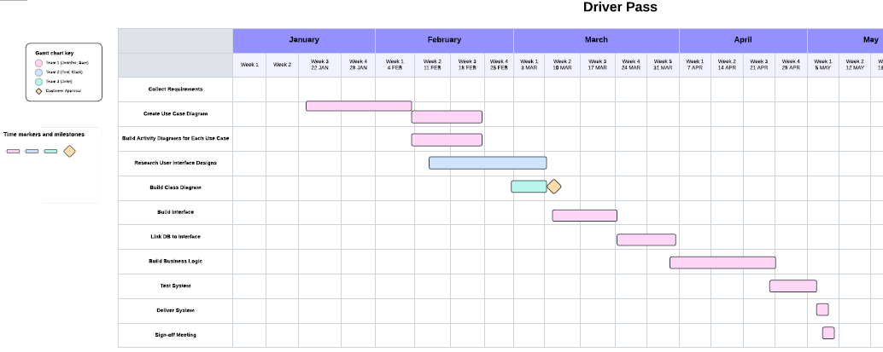

See attached PDF for a clearer visual.